Contents

Introduction 1

Business Analysis 2

IMPLEMENTATION PLAN 3

ESTABLISHING A CONNECTION 3

VIEWS 5

Figure 5: Sales View 6

Figure 6: Purchasing view 7

EXTRACT THE VIEW FROM SSMS 9

CLEANING DATA 9

CREATE AN OUTPUT TABLE 11

CREATING DIMENSIONS 12

**DATA VISUALIZATION** 15

Figure 18: Pie chart displaying gender 15

Figure 19: Bar Graph 10 job titles with most employees 16

Figure 20: Sales by company 17

Figure 21: Most bought products 19

Figure 22: Orders made in years 20

Figure 1: Most bought category 21

Conclusion 22

# Introduction

A business intelligence (BI) system is a collection of tools, technologies, and methodologies used to gather, integrate, analyze, and present corporate data to assist decision-making processes. It enables organizations to gain insights from their data and transform it into useful information, assisting them in making better informed and data-driven decisions.

By BI systems, organizations gain an insight understanding of their performance and operations across various divisions. Future results are forecasted by analyzing present and past data to find trends, patterns and anomalies. Organizations keep track on how they are doing in relation to the objectives and correct then appropriately.

The goal of the project is to develop a business intelligence system that will give AdventureWorks management access to information about their production and sales performance over time. On the other hand, the objective is to empower the management to produce decisions of higher caliber based on the insights produced by the system.

In particular, the project will consist of:

Data collection and integration: For this project, data will be collected from various systems used by AdventureWorks, including their sales and production systems. The data will then be integrated into a single data repository.

Data visualization and analysis: The project involves assessing the combined data to spot trends, patterns, and anomalies in the performance of sales and production over an array of timescales, such as monthly, quarterly, yearly, etc. To help management quickly understand the data and obtain insights, the technology will also offer interactive representations of the data findings.

Reporting and alerts: The system will offer the capacity to generate custom reports on the performance of sales and production at various time intervals for the management. The system will also provide alerts in addition.

# Business Analysis

AdventureWorks management’s business needs and requirements include:

Better decision-making: AdventureWorks' main business need is to make higher-caliber decisions that are based on data insights. To recognize trends, patterns, and anomalies in their sales and production performance over time and use this knowledge to improve their operations and bottom line, the organization wishes to obtain an in-depth understanding of their performance.

Monitoring sales and production performance: To identify areas for improvement and optimize resource allocation, the company must track its sales and production performance over a period of time, such as monthly, quarterly, and yearly. A system that can gather data from many sources, combine it, and present interactive illustrations of the data insights is necessary for this.

Customized reporting: AdventureWorks management calls for a system that can produce reports on sales and production performance that are specific to their needs and display the data in a way that is easy to comprehend. The management should be ready to make decisions based on these reports' insights into key performance indicators

The business needs a system that can send alerts and messages when specific performance metrics deviate from specified thresholds. This will make it possible for management to act appropriately and quickly, avoiding any harm to the performance of sales and production.

Since AdventureWorks uses MS SQL server

# IMPLEMENTATION PLAN

# ESTABLISHING A CONNECTION

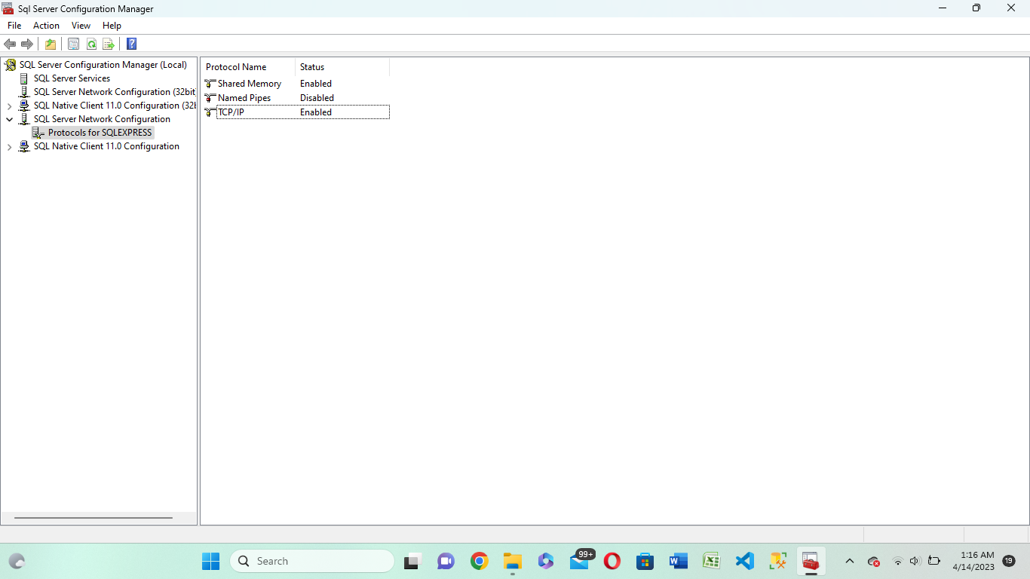

*Figure 1:*

Under the SQL server configuration manager, the SQL Server Network Configuration is expanded and under the protocol options there is a list of protocols currently configured for the SQL server. the TCP/IP is enabled and allows remote clients to connect to the SQL Server. After the TCP/IP is enabled, the applications running on the other machines can now connect to the SQL server with specific server names or the IP addresses and the TCP port numbers. On the other hand, enabling TCP/IP provides greater flexibility for configuring network settings such as setting up the firewall, load balancing or network bandwidth optimization.

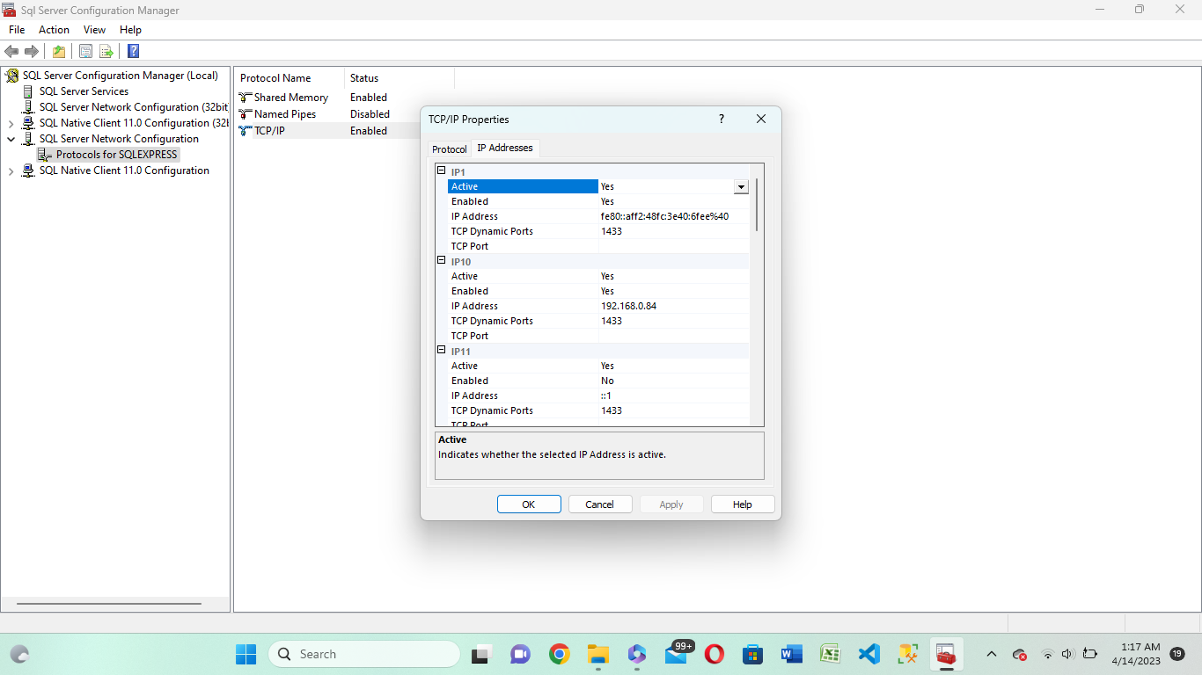

*Figure 2:*

Upon the completion of enabling TCP/IP, the port number is set to 1433. In a specific instance this allows one to specify a custom port number. The port number is now allowed in the network infrastructure and carefully configured on all client machines.

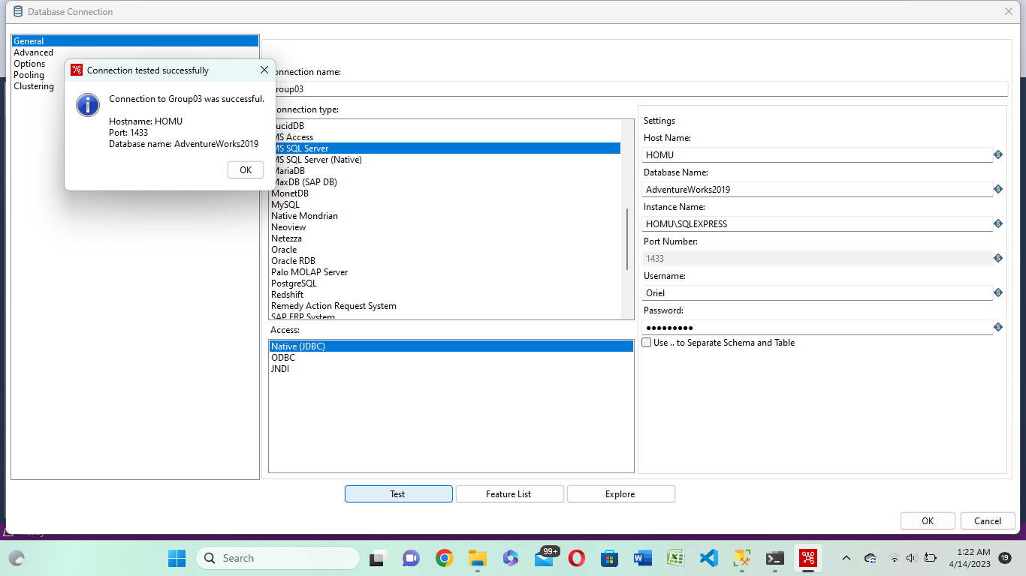

*Figure 3:*

The Testing connection is successful and it means clients can receive better responses from the server.

# VIEWS

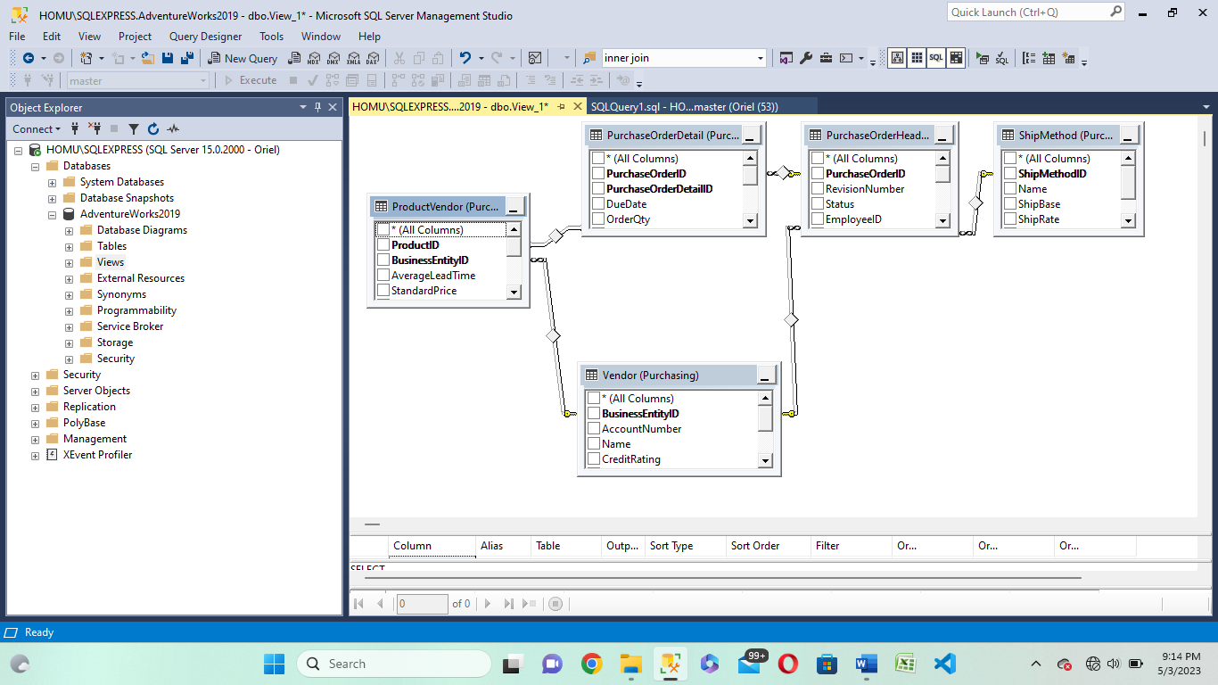

*Figure 4:*

The diagram above shows the “views” of the purchasing schema. These “views” are connected via entities. The PurchaseVendor and Vendor views are connected via the BusinessEntityID. The PurchaseOrderDetail is connected to the PurchaseOrderHead via the purchaseOrderID. With the other views, queries where implemented using the JOIN clause in SQL hence after the completed joined table there was a relationship formed between the Vendor view and the PurchaseOrderHead. Even though initially there was no common entity between them.

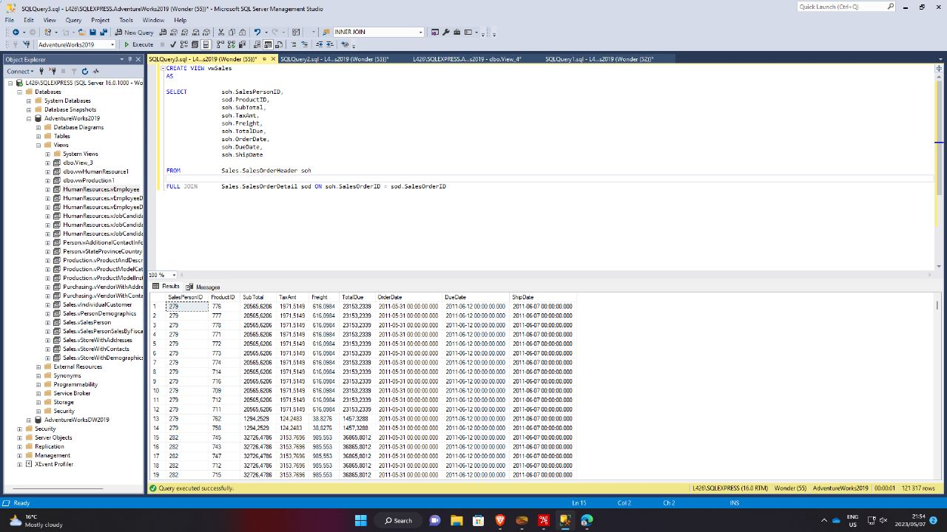

## Figure 5: Sales View

The Purchasing view includes tables such as PurchaseOrderHeader, PurchaseOrderDetail, and Vendor, among others. These tables contain information related to purchase orders, their details, and the vendors from whom the organization procures goods and services.

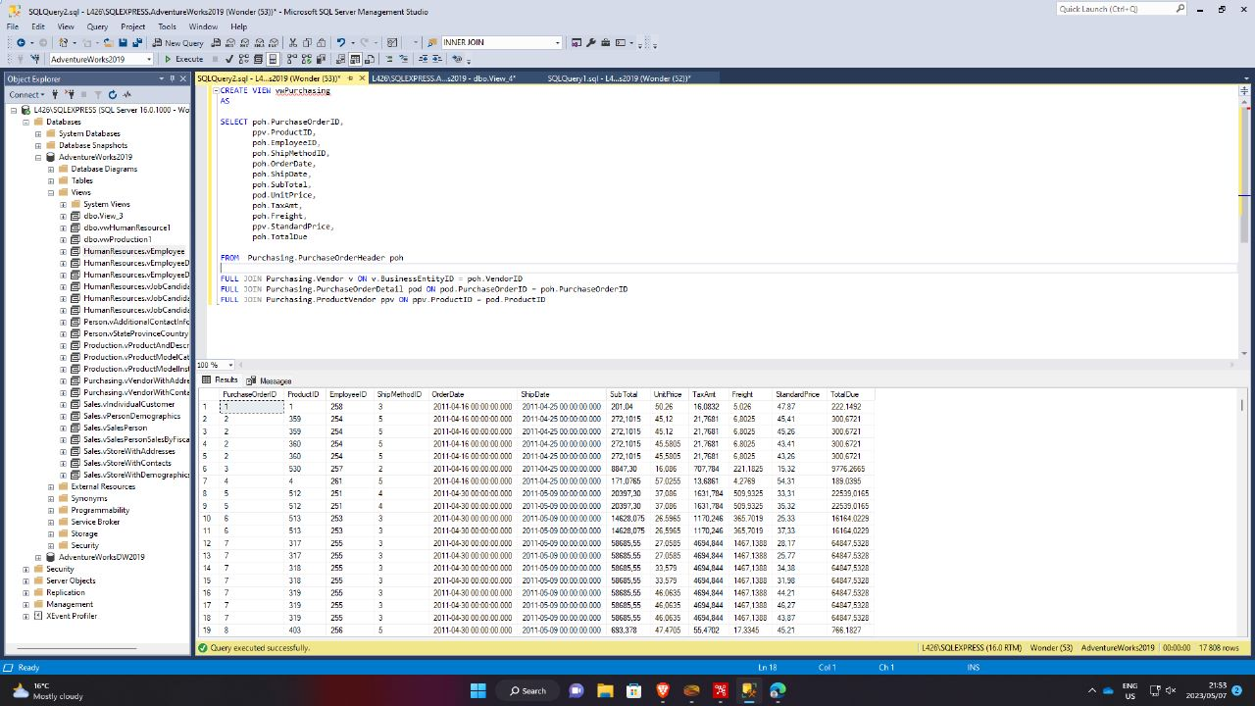

## Figure 6: Purchasing view

The HumanResources view in AdventureWorks2019 provides a convenient way to query and analyze employee data. The view combines data from multiple tables, including Employee, EmployeeAddress, EmployeeDepartmentHistory, Department, and Shift.

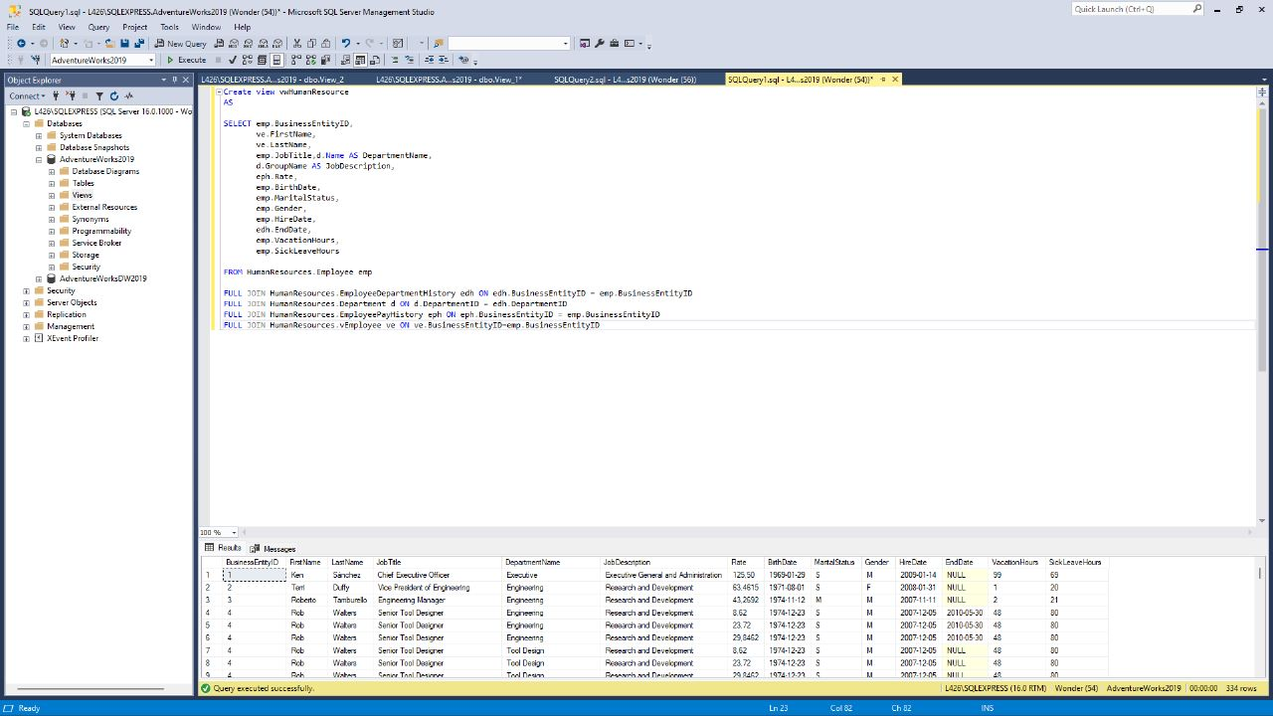

*Figure 7: humanResource view*

# EXTRACT THE VIEW FROM SSMS

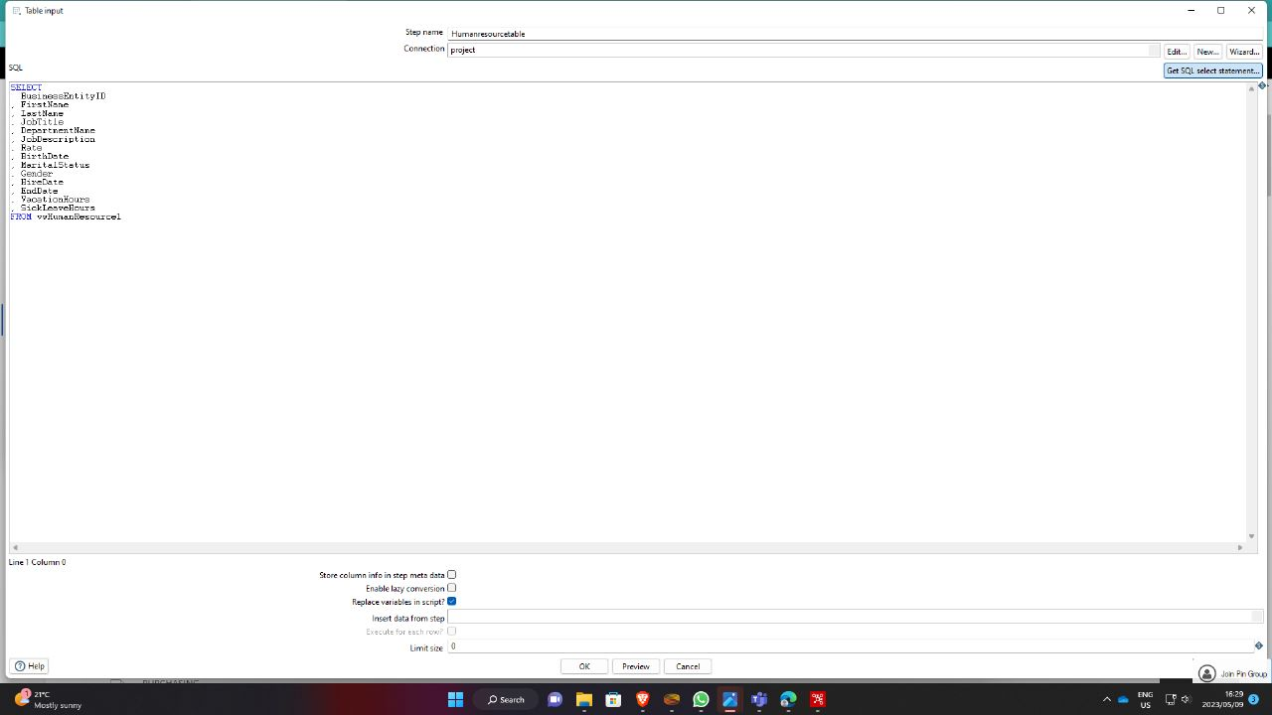

*Figure 8:*

# CLEANING DATA

In the AdventureWorks database, there are four schemas in particular which are HumanResources,

Purchasing, Sales and Production. Each one of these has a specific role. The humanResources is responsible for the management and the storage of data relating to an organization's human resource operations such as employee data, job advertisements, job titles, job descriptions and more.

The AdventureWorks database may maintain track of data including vendor information, items that are available for purchase, and the specifics of purchase orders submitted by the business through the Purchasing schema. This data can be used to check that vendors are delivering goods on time, that purchasing procedures are progressing well, and that things are being purchased at reasonable rates.

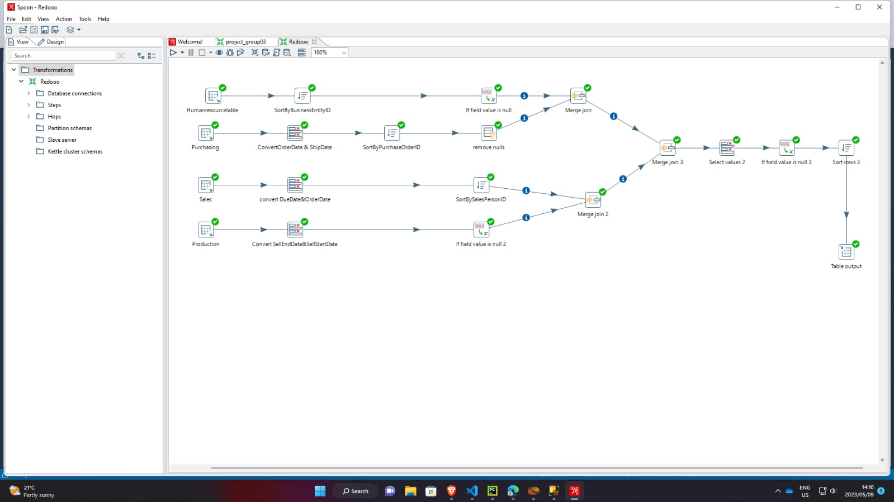

*Figure 9:*

According to the diagram, on the HumanResource schema, we took the data from AdventureWorks and focused on BusinessEntity which create a distinct legal organization that can carry out commercial operations and own assets while limiting the liabilities of the owners or shareholders. The humanresource is sorted by BusinesEntityID and if the field value is null we replaced it by N/A including the date. Finally we merged with BusinessEntity.

Under the Purchasing schema, we converted OrderDate and ShipDate to string, then we sorted by PurchaseOrderID after that we replaced nulls by N/A then we merged.

With the Sales Schema, we converted DueDate and OrderDte, then we sorted by salesprsonId and we finally we merged it by SalesPersonID.

THE FINAL schema being the product schema , we converted sellend date, we then replaced product category by zero and selldateenddate by N/A.

we then merge the two joins to one table after that we select and convert some data and remove nulls. We sort out by using BusinessEntityID, and finally we select the output table by the target table.

# CREATE AN OUTPUT TABLE

we connected our target table as tableOutPut that is in AdventureWorks2019 to store the cleaned data there.

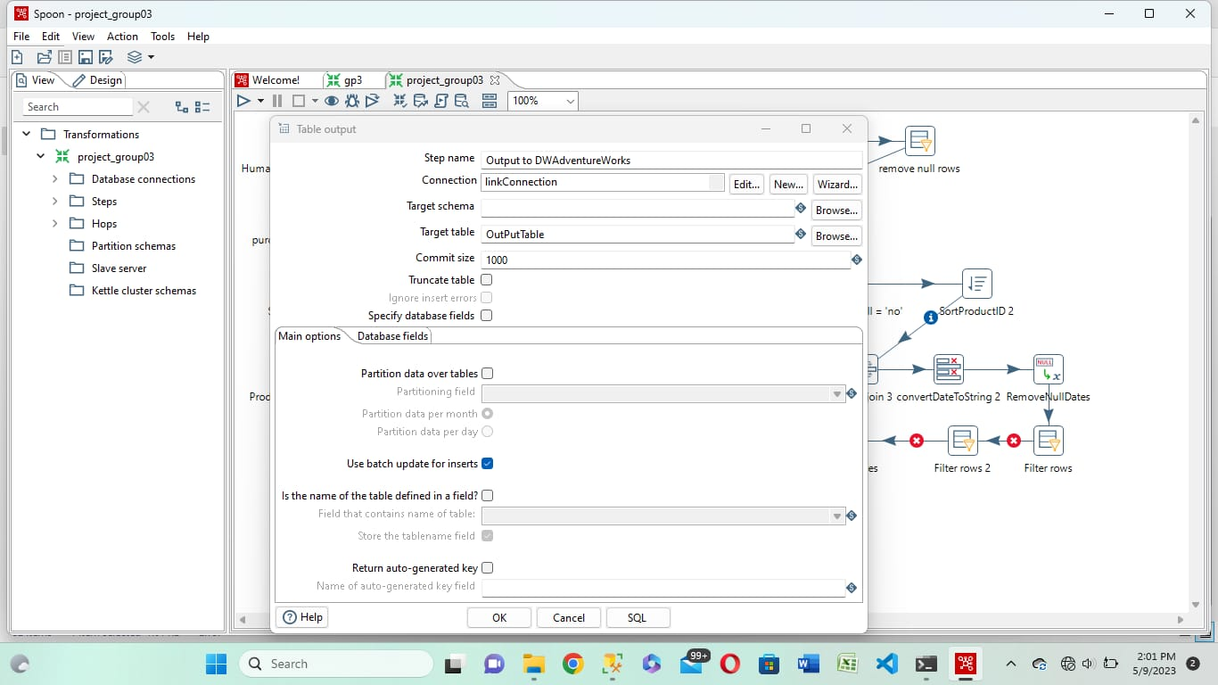

*Figure 10:*

**CREATING DATA WAREHOUSE IN SSMS and LOAD THE INPUT TABLE INTO THE DATA WAREHOUSE**

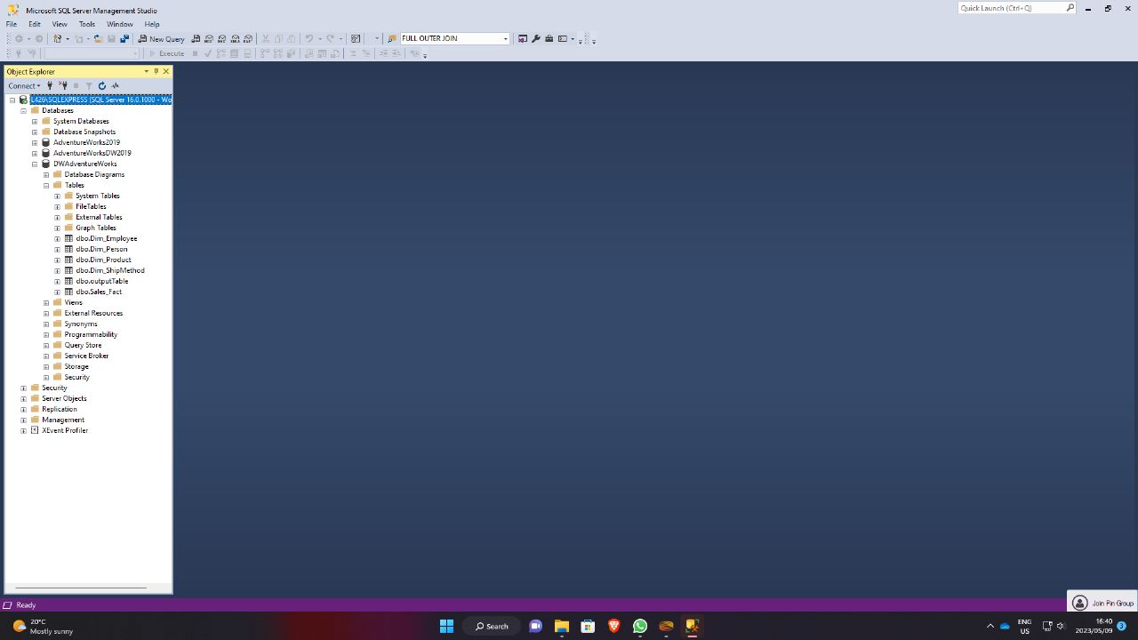

*Figure 11:*

# CREATING DIMENSIONS

This is the query that created facts tables and dimension tables as star schema

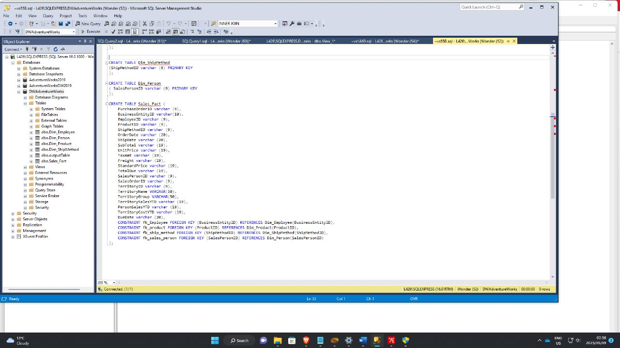

*Figure 12:*

The code continues here.

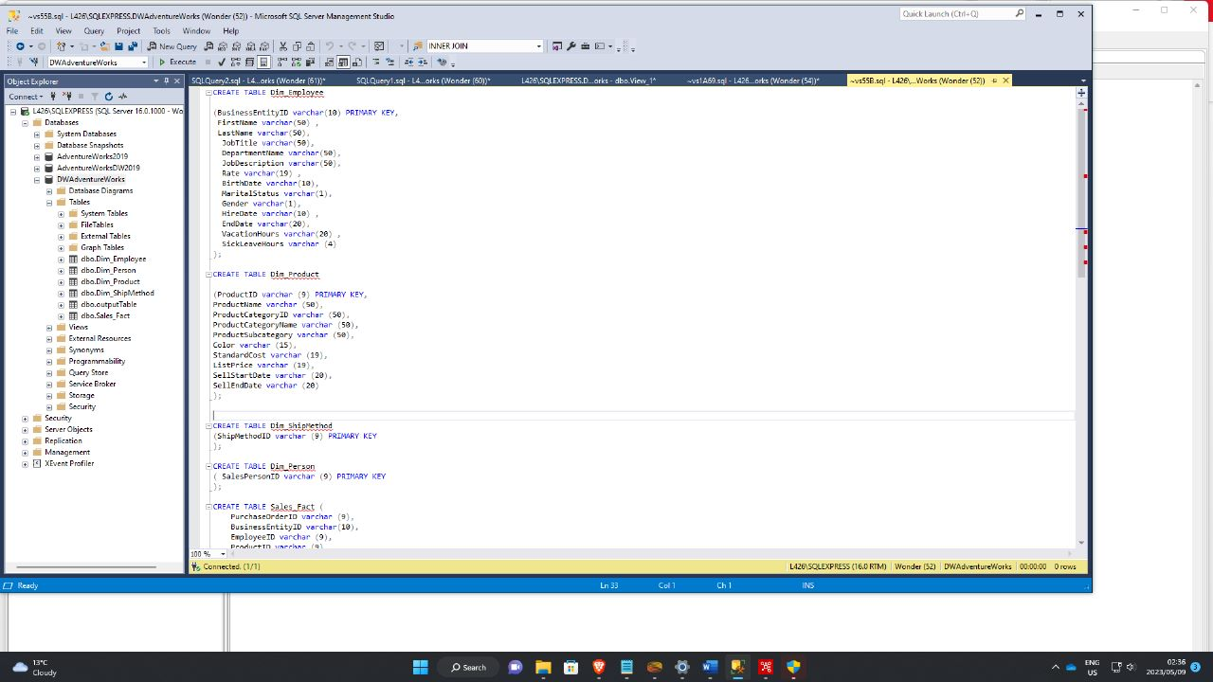

*Figure 13:*

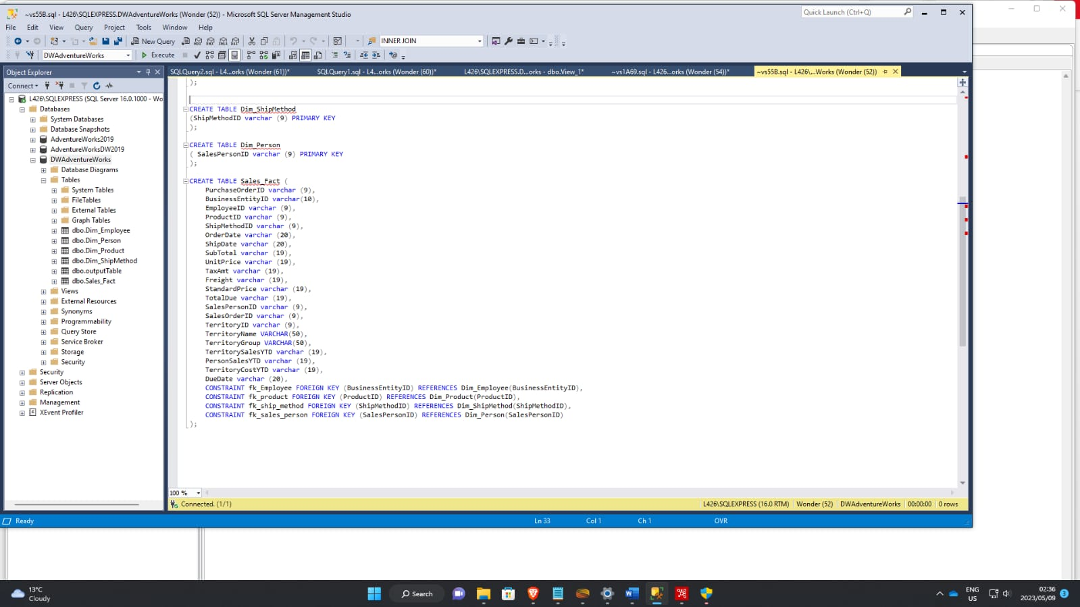

*Figure 14:*

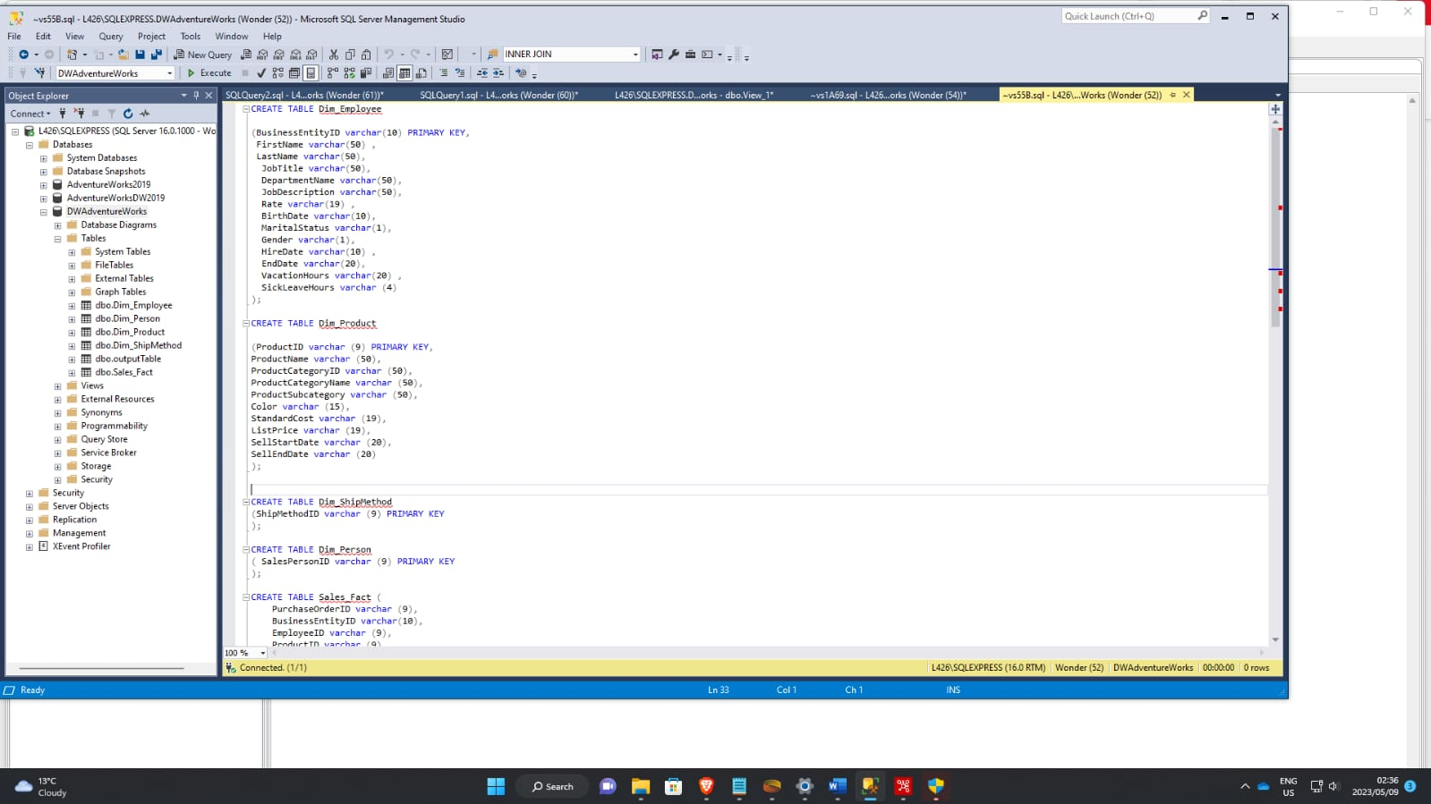

*Figure 15:*

Here we linked the tables using primary keys and foreign keys.

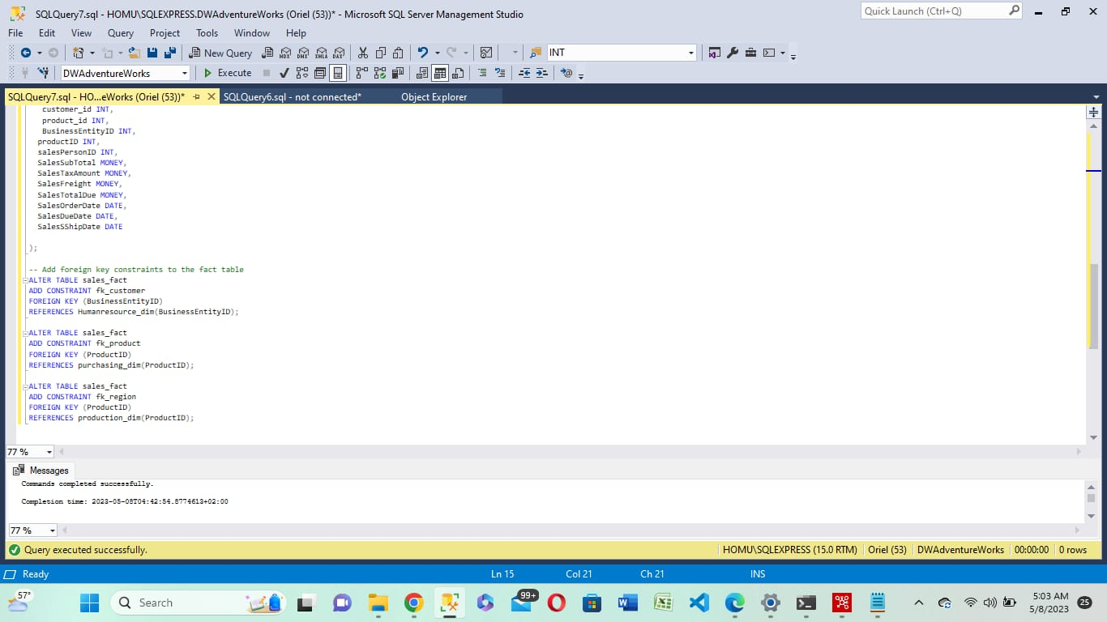

*Figure 16:*

An output that demonstrate the star schema.

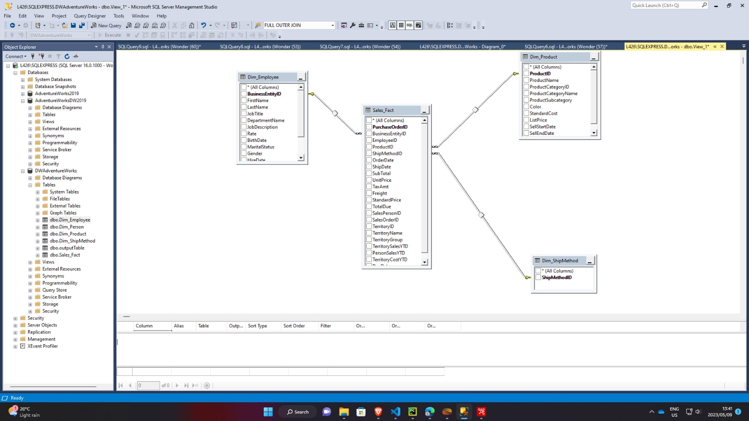

*Figure 17:*

# **DATA VISUALIZATION**

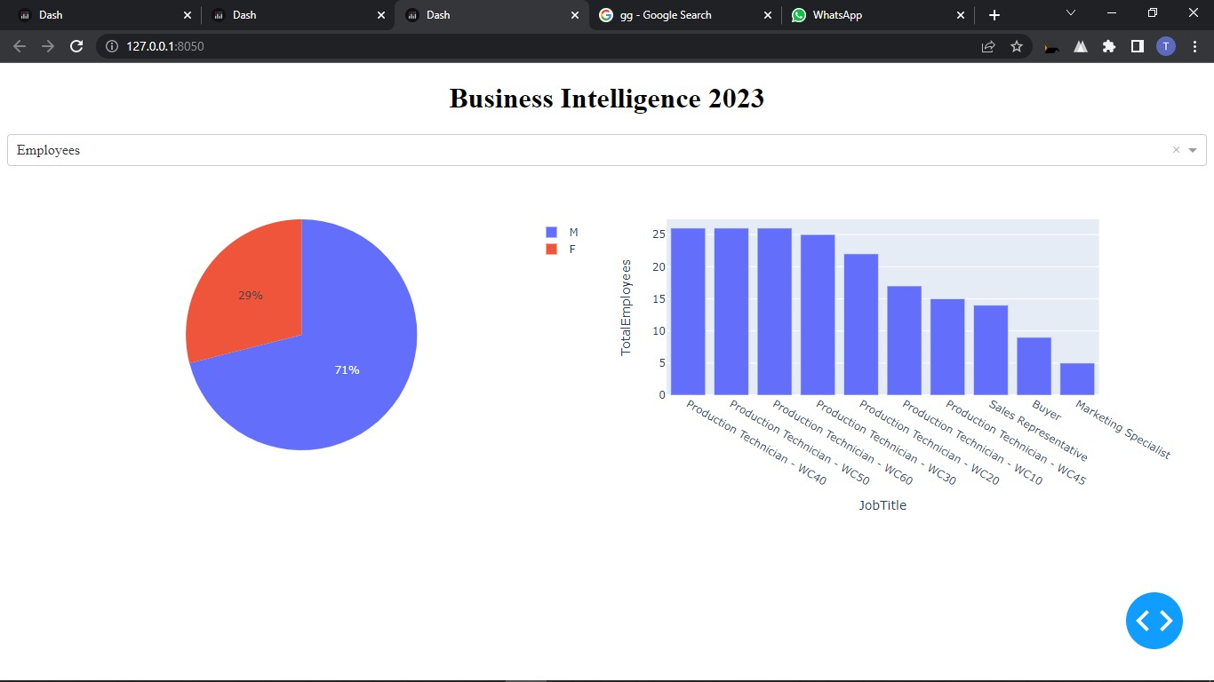

## Figure 18: Pie chart displaying gender

The pie chart represent the number of employees (males and females), the size of male employee is 71% and females is 29%. The sizes show that the company has more male employees than females.

Analyzing gender in a company can provide several benefits, including:

Promoting diversity and inclusion: By analyzing gender in a company, organizations can identify areas where there may be gender imbalances and take steps to create a more diverse and inclusive workplace. This can lead to a range of benefits, such as improved morale, increased creativity and innovation, and better problem-solving.

Addressing pay gaps: Gender analysis can also help identify any pay gaps that may exist within the company, allowing organizations to take corrective measures and ensure equal pay for all employees.

Improving hiring practices: Analyzing gender in a company can help identify any biases in hiring practices and allow organizations to implement strategies to address them. This can lead to a more diverse pool of candidates and a more equitable hiring process.

Enhancing employee satisfaction: Understanding gender dynamics in the workplace can help organizations create policies and practices that better support and accommodate all employees, which can increase overall job satisfaction and reduce turnover.

Overall, analyzing gender in a company can help create a more equitable and inclusive workplace, which can lead to a range of benefits for both the organization and its employees.



## Figure 19: Bar Graph 10 job titles with most employees

Based on the information presented in the bar graph, you can identify the sector that has a shortage of personnel, which may be an indication of where there are opportunities for hiring.Analyzing how many employees are in a particular job title can provide useful insights for various purposes, such as workforce planning, compensation analysis, talent management, and organizational design.

For example, analyzing the number of employees in a job title can help organizations determine whether they have the right number of employees in a particular role or whether there are skill gaps that need to be addressed. It can also help organizations determine whether they are paying their employees appropriately for their roles and responsibilities.

Furthermore, analyzing the number of employees in job titles can help organizations identify trends and patterns in their workforce. For example, it can help them identify areas where they may need to hire more employees or where they may need to develop existing employees' skills to meet changing business needs.

Overall, analyzing the number of employees in job titles can provide organizations with valuable insights that can help them make more informed decisions about their workforce and their business strategy.

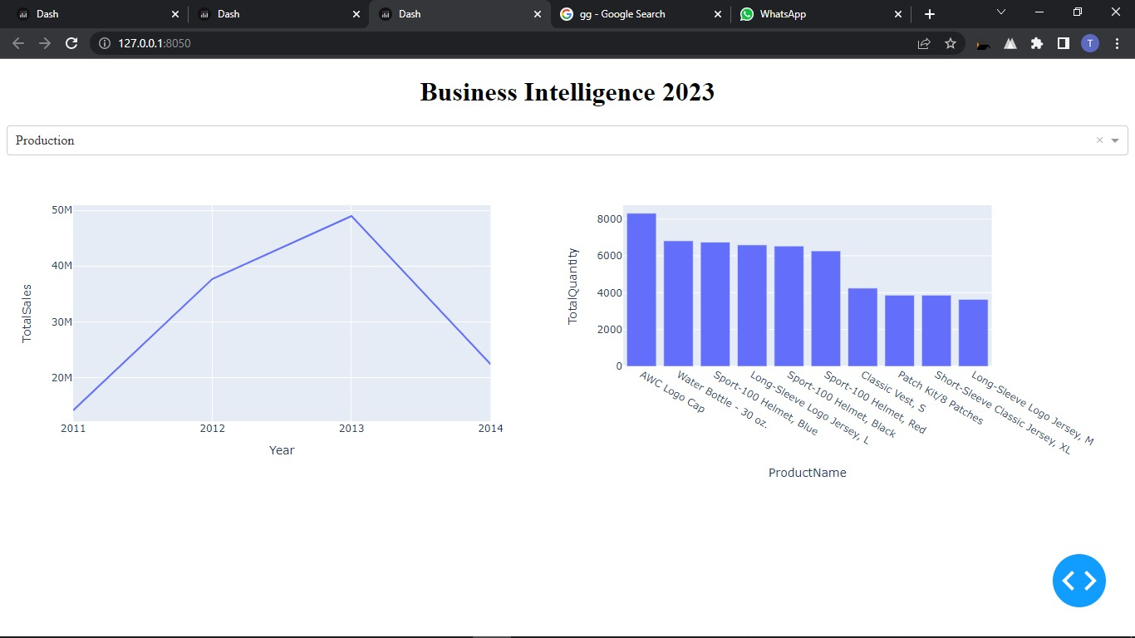

## Figure 20: Sales by company

Analyzing sales in a company is important for several reasons:

Financial performance: Sales analysis provides insights into a company's financial performance, helping managers and investors understand how much revenue the company generates and how it compares to its competitors. This information is essential for making informed business decisions and developing strategies for growth.

Forecasting: By analyzing sales data, companies can forecast future revenue and anticipate demand for their products or services. This helps them plan production, set budgets, and make other important business decisions.

Marketing effectiveness: Sales analysis can also help companies evaluate the effectiveness of their marketing campaigns. By tracking sales data before and after a campaign, companies can determine if their advertising efforts are generating a return on investment and adjust their strategies accordingly.

Identifying trends: Sales analysis can reveal trends in customer behavior and preferences. This information can be used to develop new products, improve existing ones, or tailor marketing messages to better meet customer needs.

Performance evaluation: Sales analysis can be used to evaluate the performance of individual salespeople, teams, or departments. By tracking sales data and comparing it to established goals and benchmarks, managers can identify areas for improvement and make data-driven decisions about training, coaching, and incentives.



## Figure 21: Most bought products

Analyzing the relationship between product name and total quantity can provide valuable insights into a company's sales performance. By comparing the total quantity sold for each product, companies can identify which products are the most popular and which ones may need to be re-evaluated.

For example, if one product consistently sells more than others, it may be an indication that the product is in high demand and the company should focus on increasing production or marketing efforts for that product. On the other hand, if a product consistently sells less than others, it may be an indication that the product needs to be re-evaluated, perhaps by improving its quality, changing its packaging, or adjusting its pricing.

Analyzing the relationship between product name and total quantity can also help companies identify patterns and trends in customer behavior. By examining sales data over time, companies can determine which products are seasonal or have cyclical demand, which can help them plan production and inventory levels accordingly.

Overall, analyzing the relationship between product name and total quantity can help companies make informed decisions about product development, marketing, and production, which can ultimately lead to increased sales and profitability.

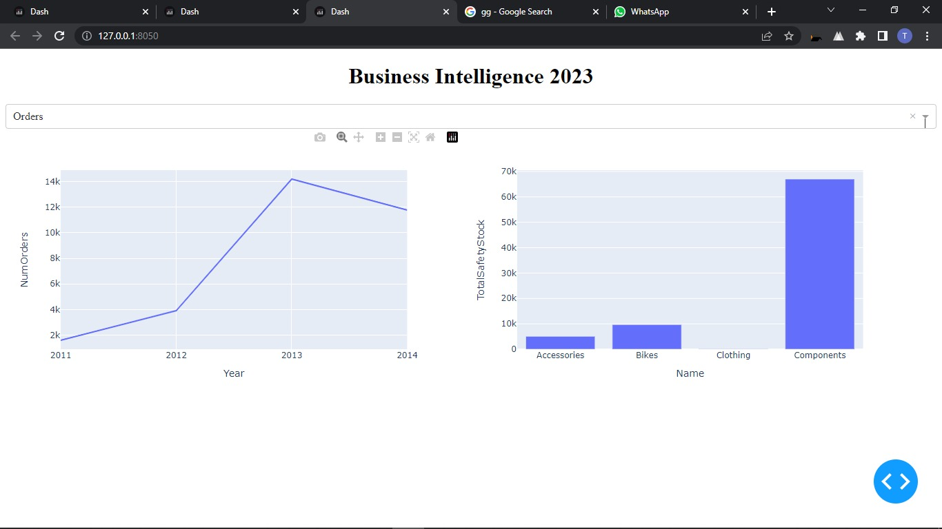

## Figure 22: Orders made in years

Analyzing orders versus years can provide valuable insights into a company's sales performance over time. By tracking the number of orders received each year, companies can determine if they are growing or declining, and identify trends and patterns that may help them make informed business decisions. For example, if the number of orders has been steadily increasing over the past few years, the company may need to invest in additional production capacity to keep up with demand. Conversely, if the number of orders has been declining, the company may need to re-evaluate its product offering, marketing strategy, or pricing to remain competitive. Additionally, analyzing orders versus years can help companies identify seasonality or cyclical trends in demand, allowing them to plan production and staffing accordingly.



## Figure 1: Most bought category

Analyzing the most purchased stocks by category name can provide valuable insights into investment trends and help investors make informed decisions. By grouping stocks into categories based on industry or sector, it is possible to identify which types of companies are most popular among investors.

For example, if a particular category consistently appears on the list of most purchased stocks, it may indicate that investors have a high level of confidence in that industry. Conversely, if a category consistently appears on the list of least purchased stocks, it may indicate that investors are wary of investing in that industry.

Analyzing the most purchased stocks by category name can also help investors diversify their portfolios. By investing in stocks from a variety of categories, investors can spread their risk and potentially earn higher returns.

Overall, analyzing the most purchased stocks by category name is a useful tool for investors to stay informed about market trends and make informed investment decisions.

# Conclusion

In conclusion, the development of a business intelligence system for AdventureWorks would significantly benefit the organization by providing valuable insights into their sales and production performance over time. The system would enable the management to make data-driven decisions based on trends, patterns, and anomalies observed in the combined data from various systems used by AdventureWorks. The implementation plan for establishing a connection to the SQL server, creating views, extracting data from SSMS, and cleaning the data has been outlined.

Moreover, the business analysis identified AdventureWorks' main business needs and requirements, including better decision-making, monitoring sales and production performance, customized reporting, and alerts for specific performance metrics. The implementation plan addresses these needs by enabling data collection and integration, data visualization and analysis, reporting, and alerts.

Furthermore, the use of MS SQL server for the business intelligence system provides a reliable and robust platform for managing the data and generating insights. The implementation plan has demonstrated how to enable TCP/IP, configure the port number, create views, and clean the data. These steps are crucial for ensuring that the system can collect, integrate, and analyze the data accurately and effectively.

In summary, the development of a business intelligence system for AdventureWorks will provide a valuable tool for management to make better-informed decisions based on data insights. The implementation plan outlined the necessary steps to establish a connection, create views, extract data, and clean it. By following this plan, AdventureWorks can achieve its business needs and requirements and obtain a competitive advantage in the market.